Writing CHEMICAL FORMULAS
Writing and understanding chemical formulas is one of the key basic skills in chemistry. A chemical formula shows the elements in a (molecule) group of atoms. Water has two hydrogen atoms and one Oxygen atoms, so it uses the symbols of H and O, and the number 2 to describe how many hydrogen there are… H₂O. This may seem obvious, but it can get complicated, and being able to understand what the symbols and numbers and brackets mean in a chemical formula helps A LOT in understanding the basics of chemistry.
Firstly – the symbols. The easiest bit. The symbols are elements in the periodic table. Each capital letter is an element. So H is hydrogen, S is sulphur, C is Carbon, N is nitrogen, and so on (you need a periodic table, one is at the end of this handout). Any lower case letter goes with the capital before it, so Ca is Calcium, Li is Lithium, Cl is Chlorine.
Second – the numbers. The number are written as subscripts… slightly below the line, and after the symbol. An example is H₂. The number is a count of how many of each symbol there are, so H₂ means each molecule contains two hydrogen atoms.

Thirdly – the brackets. Simple molecules do not have brackets in their formulas – these molecules are formed from individual atoms forming bonds - easy as. But some molecules are formed by groups of atoms forming new bonds. These more complicated molecules have brackets to describe how many atoms are in them. For example: Ca(OH)₂. This is a molecule where two OH molecules have bonded to one Ca atom. Because the OH came as a group together, we put brackets around them, and put the 2 after the (OH). Your teacher can explain why this is correct rather than CaO₂H₂.
An even more complicated example is Ca(NO₃)₂. In this molecule, two NO₃ groups have bonded to one Ca atom – so there are 1 Ca atom, two (1 x 2) N atoms, and six (3 x 2) Oxygen atoms in this molecule.

QUESTION 1 – COUNTING ATOMS
In the list of molecules below, identify (count) each type of atom in the molecule. A periodic table is at the back of this document. You can find the names of each element in there.

Chemical formula | Name and number of each type of atom
NaOH | 1 Sodium atom, 1 Oxygen atom, 1 Hydrogen atom
ZnO
CaNO₃
K₂S
NH₄F
AlCl₃
Al(OH)₃
Na₂SO₄
CuSO₄
Al₂(SO₄)₃
WRITING CHEMICAL FROMULAS
You also need to be able to write chemical formulas as well. To write a chemical formula you need to know the positive and negative charges on the atoms which make up the molecule. These charges are usually given to you in the question. Writing chemical formulas is not so hard, as long as you follow a couple of basic rules.
There are two ways to learn how to write formulas so first you have to pick a method to learn. Read both the titles below and choose which one you want to read more. Follow the guidelines and complete question 2.

Method 1 – balancing charges – for “Chemistry” students
A molecule forms by positively charged atoms being attracted to negatively charged atoms and these being stuck together because of their positive/negative attraction. So an atom (or group of atoms) attracts other atoms so long as it has a positive or negative charge. IMPORTANTLY – when the positive and negative charges balance out, the molecule becomes neutral and stops attracting atoms. The chemical formula for the molecule is now set as the numbers of atoms in the molecule will not change any more once the positive and negative charges balance to make it neutral.
So what does this look like? Say you want to write the chemical formula for calcium hydroxide.
The calcium has a 2+ charge (Ca²⁺ - look it up in the tables at the end) and the Hydroxide has a 1- charge (OH⁻ - it is Oxygen and hydrogen combined, with an overall 1- charge).
So: Ca⁺² attracts two OH⁻
2+ from one Ca, balances 2- from two OH
Ca(OH)₂ (we don’t write in the 1 for Ca)

Method 2 – translating charges – for “I just want to pass the exam” students
1. Write both parts of the molecule with their charges (which you get in the Q or in a table).
2. Warning this sounds difficult, but is exceptionally easy. Transfer the number of the charge to the subscript position (bottom right) of the other part of the molecule.
3. Check if one of parts is a group of atoms (it has more than one capital letter). If it has put brackets around it.
So: Calcium hydroxide becomes… Ca⁺² OH⁻¹
If the charge number is greater than 1 take the number and transfer it. If the charge number is 1, just write the symbols, there is no need to transfer the 1.

Ca (OH) ₂
Question 2 – Writing Formulas
Wirte the correct formulas into each empty box of the table. The charges of each part of the molecule are given to you in the table and a couple are done as examples
 | Cl ⁻ | O ⁻² | N⁻³ | OH ⁻ | NO₃ ⁻ | SO₄⁻² | PO₄⁻³
K⁺ |  | K₂O
Mg⁺²
Na⁺
Fe⁺² |  |  |  |  | Fe(NO₃)₂
Al⁺³
NH₄⁺

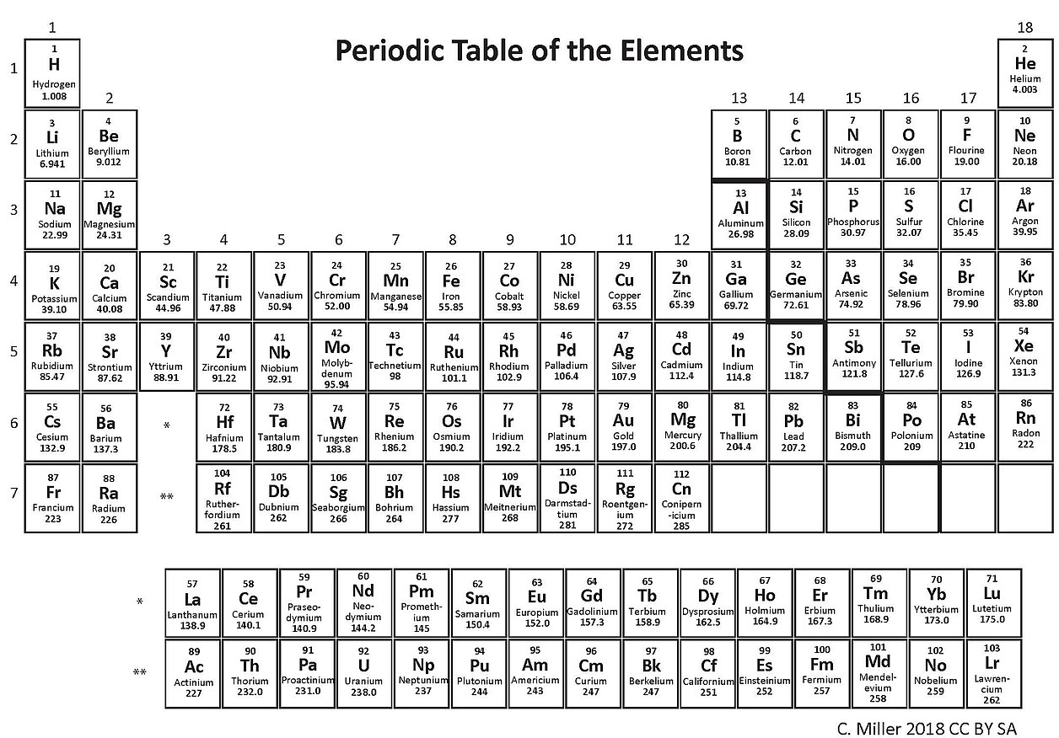
Name | Ion Charge | Symbol |  | Name | Ion Charge | Symbol
Aluminium | 3+ | Al³⁺ |  | Bromide | 1- | Br¹⁻
Ammonium | 1+ | NH₄¹⁺ |  | Carbonate | 2- | CO₃²⁻
Barium | 2+ | Ba²⁺ |  | Chlorate | 1- | ClO₃¹⁻
Calcium | 2+ | Ca²⁺ |  | Chloride | 1- | Cl¹⁻
Chromium III | 3+ | Cr³⁺ |  | Fluoride | 1- | F¹⁻
Copper I | 1+ | Cu¹⁺ |  | Hydrogen carbonate (bicarbonate) | 1- | HCO₃¹⁻
Copper II | 2+ | Cu²⁺
Gold | 3+ | Au³⁺ |  | Hydrogen sulfate (bisulfate) | 1- | HSO₄⁻
Hydrogen | 1+ | H¹⁺
Iron II | 2+ | Fe²⁺ |  | Hydroxide | 1- | OH¹⁻
Iron III | 3+ | Fe³⁺ |  | Iodide | - | I¹⁻
Lead | 2+ | Pb²⁺ |  | Nitrate | 1- | NO₃¹⁻
Magnesium | 2+ | Mg²⁺ |  | Nitrite | 1- | NO₂¹⁻
Mercury II | 2+ | Hg²⁺ |  | Oxide | 2- | O²⁻
Nickel | 2+ | Ni²⁺ |  | Phosphate | 3- | PO₄³⁻
Potassium | 1+ | K¹⁺ |  | Sulfate | 2- | SO₄²⁻
Silver | 1+ | Ag¹⁺ |  | Sulfide | 2- | S²⁻
Sodium | 1+ | Na¹⁺ |  | Sulfite | 2- | SO₃²⁻
Tin II | 2+ | Sn²⁺
Zinc | 2+ | Zn²⁺

